** Presented by**

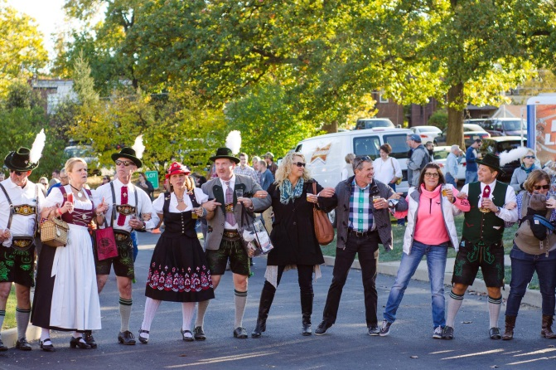  

**Saturday, October 13, 2018**

**1-5 pm**

**Francis Park’s Lilypond**

**Sampling Vendor Information and Agreement**

**Sampling Participants to Provide:**

* Product donation
* Staff of 2 people (minimum) to serve samples
* All booths must be set-up by 12:30 pm on Saturday, October 13, 2018 and remain open during event hours
* Allow the use of any images taken during the event to be used by LESA’s Brew in the Lou for publicity purposes
* Vendor must provide and/or pay for their Tent and Signage
* If possible, provide a Certificate of Insurance, naming the Lutheran Elementary School Association as a secondary insurer.

**Sampling Participants to Receive:**

* 6 foot table, linen, (4) 20# bags of ice, dump buckets, water dispensers, and tasting glass for all attendees
* Name/Logo inclusion in paid media and promotional package, valued at $150,000 or more:
  + All digital and print advertising
  + IHeart Radio On Air, Online and Onsite Promotion
  + YELP.com Online ad(s)
  + KPLR 11/Fox 2 TV, minimum 80 PSAs, pre-event coverage, possible event coverage
  + Branding through social media with onsite photo vendor
  + 1,000 Posters and 5,000 handbills distributed
  + Inclusion in the event’s comprehensive Public Relations campaign
  + Inclusion in LESA digital and print promotions
  + “Brew in the Lou” Event website, with links directed back to your brewery’s website
  + Food/Drinks
* Access to 2,500+ beer/wine/spirit loving enthusiasts

**“Brew in the Lou” Sampling Vendor Agreement for October 13, 2018**

Contact Name(s): ___________________________________________________________________________________

Business Name: _____________________________________________________________________________________

Address: _______________________________________City: ________________________State: ______ Zip: ________

Phone: _______________________ Cell Phone: ______________________ Email: _______________________________

____Check here to confirm you are able to provide your own 10’x10’ tent

____If tent is needed, there is a fee of $125 – make checks payable to: **Lutheran Elementary School Assn.**

____Check here if you need electricity

____Yes, I will help with promotion ____# of Promotional Posters _____# of Promotional Handbills

Facebook:____ [www.facebook.com/LESASTL](http://www.facebook.com/LESASTL) Instagram: [www.instagram.com/lutheranelemantarystl](http://www.instagram.com/lutheranelemantarystl)

Twitter Handle: https://twitter.com/brewintheloustl

Detailed Description of product(s) or service(s) you will be selling or providing: ________________________________________________________________________________________________________________________________________________________________________________________________________________________________________________________________________________________________________________________________________________________________________________________________________

*Release and acceptance of Rules – I/we the applicant(s), do expressly release the organizers of event from any and all liability for any damage, injury, or loss to any person, business, or property which may arise from licensing and occupation of the exhibit space by the applicant(s), and agree to hold and save organizers harmless of any damage, injury or less by reason thereof.*

Signature of Vendor ___________________________________________ Date __________________________

**TO BENEFIT THE**

