

Saturday, October 12, 2019  
1-5 pm - Francis Park

*To Benefit Lutheran Education*

*Sampling Form*

Presented by

**Saturday, October 13, 2018**

**1-5 pm**

**Francis Park’s Lilypond**

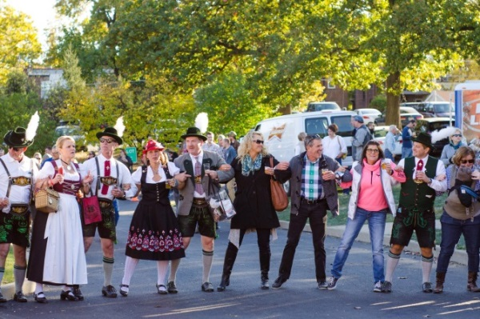



**Sampling Participants to Provide:**

* Product donation for 2,500 consumers throughout the event
* Staff of 2 people (minimum) to serve samples. Volunteers available to assist as needed
* All booths must be set-up by 12:30 pm on Saturday, October 12, 2019 and remain open during event hours
* Allow the use of any images taken during the event to be used by LESA’s Brew in the Lou for publicity purposes
* Vendor must provide and/or pay for their Tent and Signage
* If possible, provide a Certificate of Insurance, naming the Lutheran Elementary School Association as a secondary insurer.
* Allow the use of any images taken during the event to be used by LESA’s Brew in the Lou for publicity purposes

**Sampling Participants to Receive:**

* 8 foot table, linen, ice, dump buckets, water dispensers, and tasting glass for all attendees
* Name/Logo inclusion in printed and digital promotional materials:
  + All digital and print advertising and promotion
  + KPLR 11/Fox 2 TV, pre-event promotion, possible event coverage
  + Branding through social media
  + Posters and 5,000 handbills distribution
  + Inclusion in the event’s comprehensive Public Relations campaign
  + “Brew in the Lou” Event website, with links directed back to your website
  + Food/Drinks
* Access to 2,500+ beer/wine/spirit loving enthusiasts for consumer on-site activation

**“Brew in the Lou” Sampling Vendor Agreement for October 12, 2019**

Contact Name(s): ___________________________________________________________________________________

Business Name: _____________________________________________________________________________________

Address: _______________________________________City: ________________________State: ______ Zip: ________

Phone: _______________________ Cell Phone: ______________________ Email: _______________________________

____Check here to confirm you are able to provide your own 10’x10’ tent

____If tent is needed, there is a fee of $150 – make checks payable to: **Lutheran Elementary School Assn.**

____Yes, I want to enter the Bratwurst Competition _____Yes, I want to enter the chili cook-off competition

____Check here if you need electricity

____Yes, I will help with promotion ____# of Promotional Posters _____# of Promotional Handbills

Facebook:____ [www.facebook.com/LESASTL](http://www.facebook.com/LESASTL) Instagram: [www.instagram.com/lutheranelemantarystl](http://www.instagram.com/lutheranelemantarystl)

Twitter Handle: https://twitter.com/brewintheloustl

Detailed Description of product(s) or service(s) you will be selling or providing: ________________________________________________________________________________________________________________________________________________________________________________________________________________________________________________________________________________________________________________________________________________________________________________________________________

*Release and acceptance of Rules – I/we the applicant(s), do expressly release the organizers of event from any and all liability for any damage, injury, or loss to any person, business, or property which may arise from licensing and occupation of the exhibit space by the applicant(s), and agree to hold and save organizers harmless of any damage, injury or less by reason thereof.*

Signature of Vendor ___________________________________________ Date __________________________

**TO BENEFIT THE**

