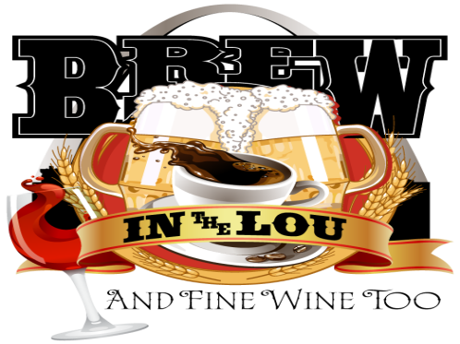

**Saturday, October 12, 2019  
1-5 pm - Francis Park  
Presented by**



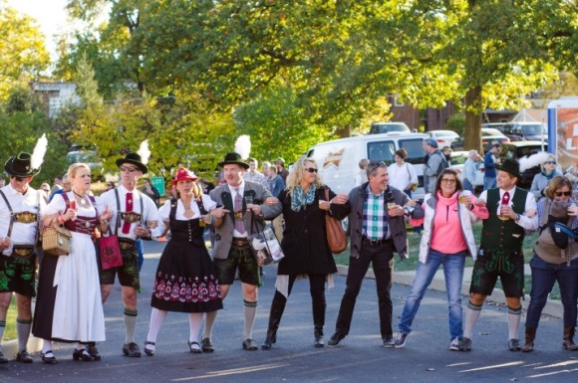



**Vendor Selling Agreement**

Contact Name:____________________________________ Business Name:___________________________________

Address:_______________________________________City:__________________State:_______________Zip ________

Phone:_______________________ Cell Phone: ______________________Email: _______________________________

* Vendor selling fee is $75 includes 2 chairs, one 8’ table, electricity. Must be set-up by 12:00 pm.
* If a food vendor, you must provide samples for 2,500 attendees of 2 different food items ***throughout entire event.*** Menu to be approved by Katherine Auble by August 31, 2019.
* Sales Permitted for gift certificates, merchandise, packaged foods, non-alcoholic beverages, food (other than sample items).  **Sales are only permitted as long as samples are available.**
* Any related expenses will be considered a tax-deductible charitable donation to LESA.
* Must provide at least 2 staff members to assist. Volunteers will also be assigned to assist in distribution.
* Must secure temporary food permit
* Allow the use of any images taken during the event to be used by LESA’s Brew in the Lou for publicity purposes

____Check here to confirm you will provide your own 10’x10’ tent.  
____If tent is required to be provided by LESA, there is an additional fee of $150  
____Yes, I want to enter the bratwurst competition ____Yes, I want to enter the chili competition  
____Yes, I will sell wristbands. Discount code is STLEATS  
____Yes, I will help with promotion. #brewinthelou ___# of Promotional Posters ___# of Promotional Handbills

# Facebook:____ @lesabrewinthelou  Instagram: @brewintheloustl Twitter Handle: @brewintheloustl

Detailed Description of product(s) or service(s) you will be selling or providing: ______________________________________________________________________________________________________________________________________________________________________________________________________________________________________________________________________________________________________

*Release and acceptance of Rules – I/we the applicant(s), do expressly release the organizers of event from any and all liability for any damage, injury, or loss to any person, business, or property which may arise from licensing and occupation of the exhibit space by the applicant(s), and agree to hold and save organizers harmless of any damage, injury or less by reason thereof.*

Signature of Vendor ___________________________________________ Date__________________________