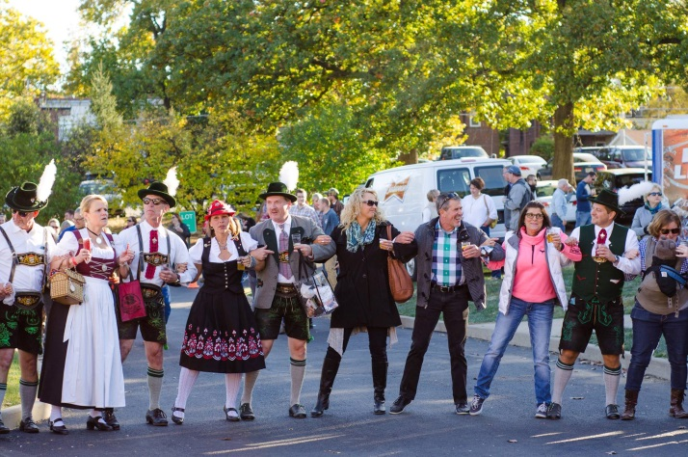

**Saturday,**

**October 14, 2017,**

**Francis Park**

**1-5 p.m.**

**Saturday, October 13, 2018**

**1-5 pm**

**Francis Park’s Lilypond**

**Vendor Agreement**

Contact Name:____________________________________ Business Name:___________________________________

Address:_______________________________________City:__________________State:_______________Zip ________

Phone:_______________________ Cell Phone: ______________________Email: _______________________________

____Vendor fee is $50 includes 2 chairs, one 8’ table and table cover. Must be set-up by 12:00 pm.

____Check here to confirm you are able to provide your own 10’x10’ tent.

____If tent is required to be provided by LESA, there is an additional fee of $125

____If electricity is required to be provided by LESA, there is an additional fee of $100.

____Yes, I will help with promotion. ____# of Promotional Posters _____# of Promotional Handbills

Facebook:____ [www.facebook.com/LESASTL](http://www.facebook.com/LESASTL) Instagram: [www.instagram.com/lutheranelemantarystl](http://www.instagram.com/lutheranelemantarystl)

Twitter Handle: https://twitter.com/brewintheloustl

Detailed Description of product(s) or service(s) you will be selling or providing: ________________________________________________________________________________________________________________________________________________________________________________________________________________________________________________________________________________________________________________________________________________________________________________________________________

*Release and acceptance of Rules – I/we the applicant(s), do expressly release the organizers of event from any and all liability for any damage, injury, or loss to any person, business, or property which may arise from licensing and occupation of the exhibit space by the applicant(s), and agree to hold and save organizers harmless of any damage, injury or less by reason thereof.*

Signature of Vendor ___________________________________________ Date__________________________